# Introduction

## Purpose

The Software System Specification defines and describes the specification of the EPD ICU Software of the SRG Mission.

## Scope

This document applies to the EPD ICU Software of the SRG Mission. It does not provide information for the Ground Support Software (GSS), which is maintained separately as part of the Electronic Ground Support Equipment (EGSE). This document supplies information applicable to the Software System Specification.

# Applicable Documents

AD1 Software. ECSS-E-ST-40C. 06/03/2009

AD2 Software Product Assurance. ECSS-Q-ST-80C. 06/03/2009

AD3 SRG-EPD Software Product Assurance Plan. SRG-EPD-SPA-0001

AD4 SRG-EPD Software Development Plan. SRG-EPD-SDP-0001

# Reference Documents

RD1 CCSDS Packet Telemetry. CCSDS 102.0-B-5. Blue Book. SO-EPD-PO-IF-0001. 11/2000

RD2 Ground systems and operations - Telemetry and telecommand packet utilization. ECSS-E-70-41C. 15/04/2016

RD3 SpaceWire - Links, nodes, routers and networks. ECSS-E-ST-50-12A. 24/01/2003

RD4 SpaceWire - CCSDS packet transfer protocol. ECSS-E-ST-50-53C

RD5 Space engineering. Electric and electronic. ECSS-E-20B issue 8 rev 0. 03/2007

RD6 Spacecraft discrete interfaces. ECSS-E-ST-50-14C

# Terms, Definitions and Abbreviations

AD Applicable Document

ASW Application Software

BSW Boot Software

C&DH Control and Data Handling

CDPU Common Data Processing Unit

EGSE Electrical Ground Support Equipment

EPD Energetic Particle Detector

GSS Ground Support System

ICU Instrument Control Unit

IRQ Interrupt Request

FPGA Field Programmable Gate Array

LVPS Low Voltage Power Supply

OBDH On-Board Data Handling

RAM Random Access Memory

RD Reference Document

S/C Spacecraft

SDRAM Synchronous Dynamic RAM

SVVP Field Programmable Gate Array

SW Software Verification and Validation Plan

TBC To Be Confirmed

TC Telecommand

TM Telemetry

# General Description

## Product Perspective

The SRG Mission has been conceived to study the effect of high energy particles in TBD environment. The SRG Energetic Particle Detector (EPD) suite consists of four sensors measuring TBD particles. SRG EPD ICU Software purpose is to provide support to EPD sensors.

## General Capabilities

**The main capabilities of the SRG EPD ICU Software are the following:**

* To collect scientific data from the instruments periodically.
* To accumulate high-cadence science data from the sensors to specified lower time resolution packages.
* To collect housekeeping data from the four units.
* To time tag the data if necessary.
* To perform lossless compression of the data if necessary.
* To format the data for transmission by the S/C.
* To accept and syntactically check TC from the S/C.
* To deliver these commands to the individual sensors for execution.
* To accept and syntactica
* To deliver these commands to the individual sensors for execution.
* To accept from the ground and distribute to the sensors tables and software.
* To handle the burst mode.

## General Constraints

The read-only memory available for the storage of SRG EPD ICU Boot Software will be TBD MBytes.

The non-volatile memory available for the storage of SRG EPD ICU persistent data and Application Software will be TBD MBytes.

The memory available to SRG EPD ICU Software for sensor science storage will be limited to TBD MBytes.

## Operational Environment

Figure 1 illustrates the EPD Instrument Control Unit operational environment.

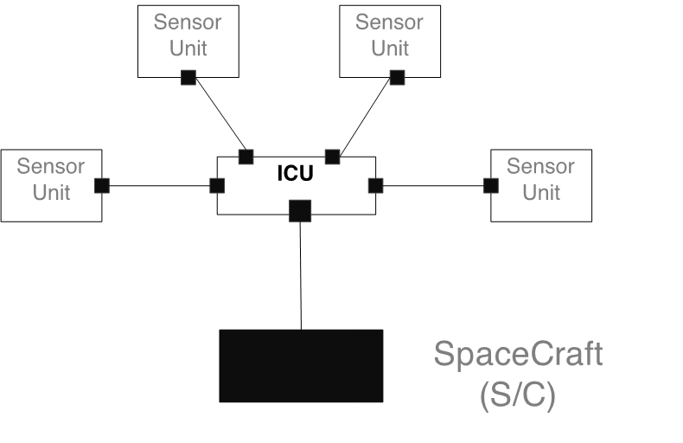

Figure 1: ICU Interfaces

EPD's ICU provides the interface between the SRG Spacecraft C&DH system and the EPD sensors. All information transfer between the EPD's sensors and the Spacecraft/Ground flows through the ICU, including telemetry, commands and status. The EPD's sensors communicate with the EPD's ICU over a dedicated serial interface.

### Sensors Interface

EPD ICU Software will send/receive telecommand/telemetry to/from the sensors. The telemetry information includes both scientific and housekeeping data. The telecommand information includes sensors tables, sensor software and ground commands delivered from the S/C to the EPD ICU.

### S/C Interface

EPD ICU is a remote terminal on the spacecraft SpaceWire link. The implementation will be compliant up to the RD2 and RD3. Two separate SpaceWire links in a hot redundant configuration will be employed. SpaceWire is the command and data interface with the S/C.

EPD command messages are contained in CCSDS telecommand packets. EPD CDPU strips off the CCSDS packet headers and analyses the destination identifier. If the identifier is associated to the ICU, the telecommand is processed directly by the ICU. If the identifier is associated to any sensor, the ICU forward the command to the specific sensor. Command responses from the sensor are sent to the ICU that transmits them to the S/C in CCSDS telemetry packets format. Command responses generated by the ICU itself are also CCSDS formatted and transmitted to the S/C.

Transfer of data and command response from CDPU to the S/C shall take place according to the CCSDS recommendations defined in RD1 and RD2.

## Assumptions Dependencies

N/A

# Specific Requirements

In the following paragraphs a lists of software specific requirements will be included. Every single requirement has the following format:

| Name | SSS-ICUSW XX-YYYY |
| Description |  |
| Validation | Validation Approach |

**SSS-ICUSW XX-YYYY:** Identifies the specification requirement. XX is the type of specification requirement and YYYY is the number used to identify the requirement. Types of specification requirements are:

* **GE.** General
* **CA.** Capabilities
* **IF.** System Interface
* **AM.** Adaptation and missionization
* **CR.**Computer resource requirements
* **SE.** Security
* **SA.** Safety
* **RA.** Reliability and availability
* **QU.** Quality
* **DC.** Design and Constraints
* **SO.** Software Operations
* **SM.** Software Maintenance
* **OB.** System and Software observability

Examples:

* SSS-ICUSW CA-0025
* SSS-ICUSW SO-0047

**Description:** is the text that describes the requirement.

**Validation approach:** establishes how the requirement is verified:

* **R.** Review
* **A.** Analysis
* **I.** Inspection
* **T.** Test
* **S.** Similarity

For each requirement type, subsections are provided when requirements apply only to boot software or to application software or they are common.

Other subsections or extended descriptions can be also added in order to better organize and clarify the requirements.

Extended descriptions and clarifications will be added using **D:**. Example:

D: The ICU SW shall handle the telecommand and telemetry according to the following requirements:

## General Requirements

|  |  |
| --- | --- |
| **Name** | **SSS-ICUSW-GE-010** |
| **Description** | The ICU SW Development Process shall be compliant to a tailored version of the software standard AD1. |
| **Validation Method** | Review |

## Capabilities Requirements

|  |  |
| --- | --- |
| **Name** | **SSS-ICUSW-CA-010** |
| **Description** | The ICU-SW shall accept telecommands within an interval of 1 second after its reception. |
| **Validation Method** | Analysis |

## System Interface Requirements

|  |  |
| --- | --- |
| **Name** | **SSS-ICUSW-IF-010** |
| **Description** | The ICUSW shall support a simplified version of PUS service 1: Telecommand verification service. |
| **Validation Method** | Testing |

## Adaptation Missionization Requirements

## Computer Resource Requirements

## Security Requirements

## Safety Requirements

## Reliability Availability Requirements

## Quality Requirements

## Design Requirements

## Software Operations Requirements

## Software Maintenance Requirements

## System Software Observability Requirements

# Verification Validation Integration Requirements

In the following paragraphs a lists of verification, validation and system integration requirements will be included. Every single requirement has the following format:

| Name | SSS-ICUSW XX-YYYY |
| Description |  |
| Validation | Validation Approach |

**SSS-ICUSW XX-YYYY:** Identifies the specification requirement. XX is the type of specification requirement and YYYY is the number used to identify the requirement. Types of specification requirements are:

* **VV.** Verification and validation process
* **VA.** Validation approach
* **VR.** Validation requirement
* **VE.** Verification approach

Examples:

* SSS-ICUSW CA-0025
* SSS-ICUSW SO-0047

**Description:** is the text that describes the requirement.

**Validation:** Validation of these requirements will be by Review (**R**).

For each requirement type, subsections are provided when requirements apply only to boot software or to application software or they are common.

Other subsections or extended descriptions can be also added in order to better organize and clarify the requirements.

Extended descriptions and clarifications will be added using **D:**. Example:

D: The ICU SW shall handle the telecommand and telemetry according to the following requirements:

## Verification Validation Process Requirements

|  |  |
| --- | --- |
| **Name** | **SSS-ICUSW-VV-010** |
| **Description** | The ICU Software verification and validation activities shall be defined in a Software Validation and Verification Plan according to the software standard ECSS-E-ST-40C. |
| **Validation Method** | Review |

## Validation Approach

|  |  |
| --- | --- |
| **Name** | **SSS-ICUSW-VA-010** |
| **Description** | The SRG EPD ICU Software specification specific requirements shall be validated primarily by test or analysis, being the analysis the required method when the specific requirement imply the fulfillment of temporal restrictions. |
| **Validation Method** | Review |

|  |  |
| --- | --- |
| **Name** | **SSS-ICUSW-VA-020** |
| **Description** | The unit and integration tests of the SRG EPD ICU Software shall be executed primarily on ICU engineering models or simulators of the ICU processor, so the object code behavior of the item under test can be tested. |
| **Validation Method** | Review |

|  |  |
| --- | --- |
| **Name** | **SSS-ICUSW-VA-030** |
| **Description** | The validation tests of the SRG EPD ICU Software shall be executed primarily on the ICU EQM models, using emulators to replace the sensors that are connected to the ICU EQM interfaces. For fault tolerance tests, the use fault injection environments based on ICU emulators or simulators shall be also accepted under justification. |
| **Validation Method** | Review |

|  |  |
| --- | --- |
| **Name** | **SSS-ICUSW-VA-040** |
| **Description** | The qualification tests of the SRG EPD ICU Software shall be executed primarily on the ICU EQM models, using qualification models of the sensors, and an S/C emulator. For fault tolerance tests, the use fault injection environments based on ICU emulators or simulators shall be also accepted under justification. |
| **Validation Method** | Review |

|  |  |
| --- | --- |
| **Name** | **SSS-ICUSW-VA-050** |
| **Description** | The acceptance tests of the SRG EPD ICU Software shall be executed on the ICU PFM models, using PFM model of the sensors, and the PFM S/C. |
| **Validation Method** | Review |

## Validation Requirements

|  |  |
| --- | --- |
| **Name** | **SSS-ICUSW-VR-010** |
| **Description** | The SRG EPD ICU Software specification specific requirement shall include a validation method from one of the following methods: Review, Analysis, Inspection, Test, Similarity |
| **Validation Method** | Review |

## Verification Requirements

|  |  |
| --- | --- |
| **Name** | **SSS-ICUSW-VE-010** |
| **Description** | Verification of the SRG EPD ICU Software shall include the following traceability matrices:   * specification requirements to software requirements * software requirements to software validation specification * software validation specification to software validation reports * software items under configuration to software unit/integration test * software unit/integration test to software unit/integration reports * TM/TC interface control document to software validation specification * FDIR EPD system requirement to software validation specification |
| **Validation Method** | Review |

# System Models